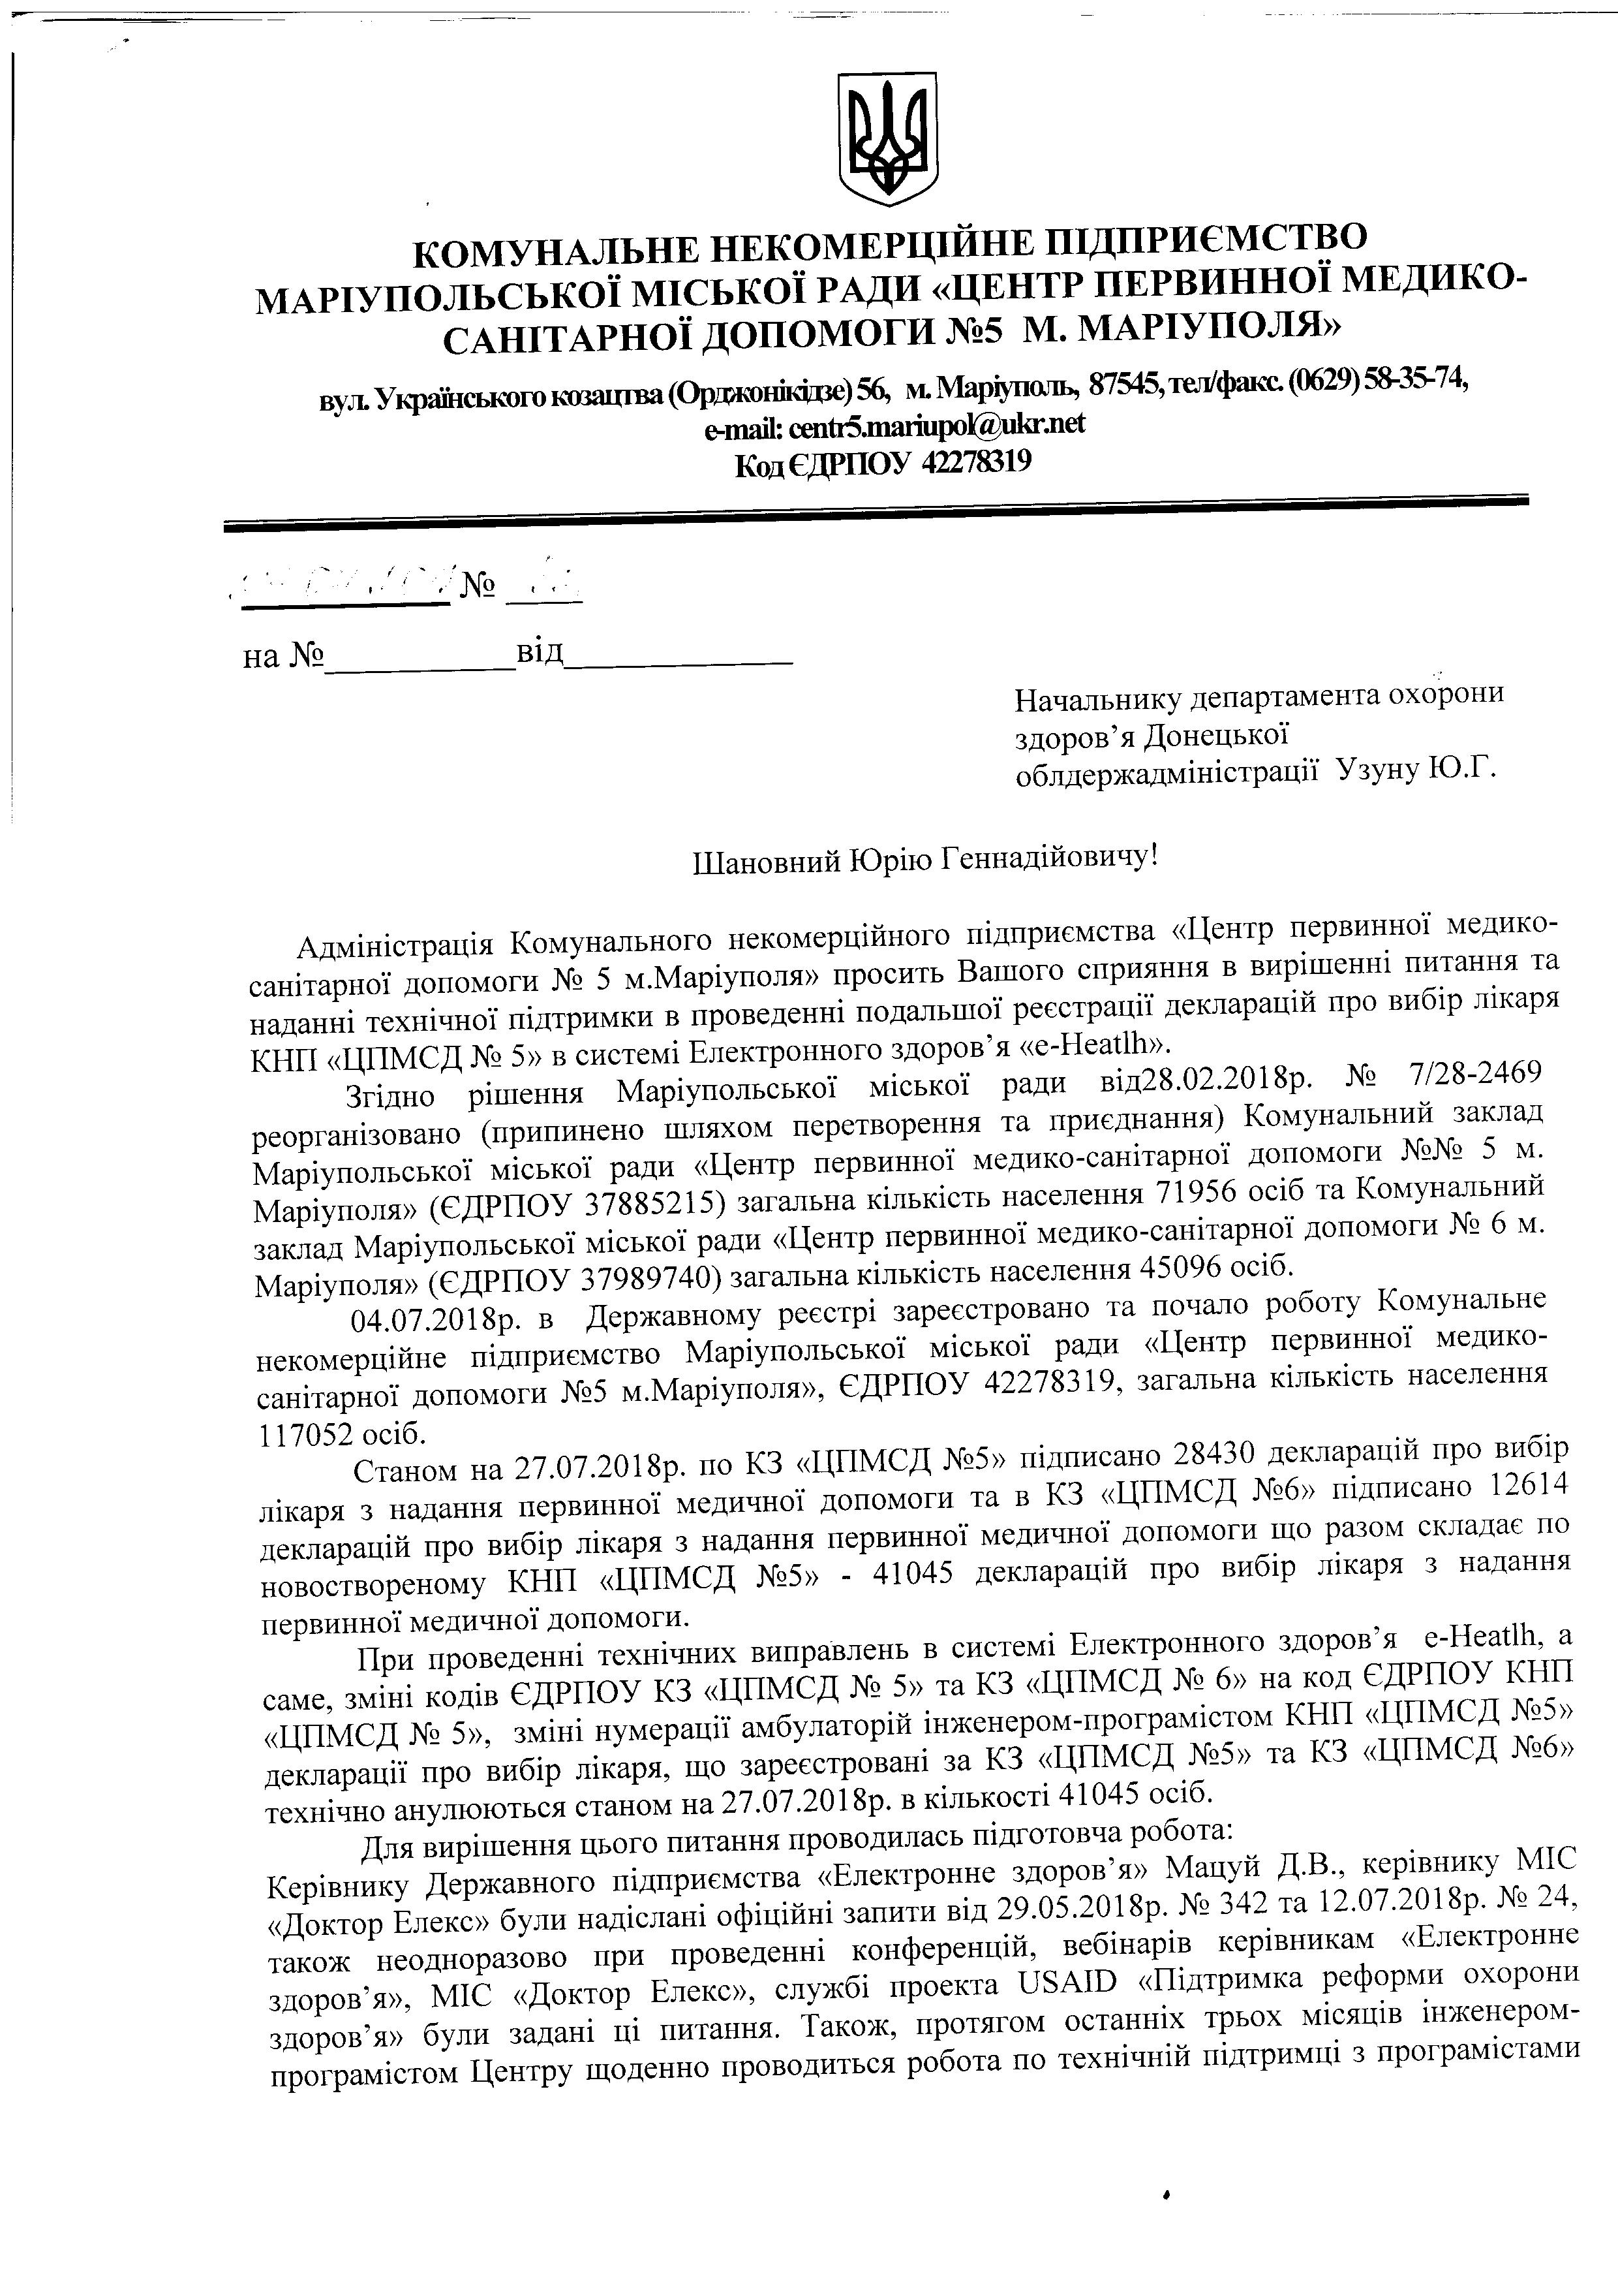
_{KOMYHAJTbHE} HEKOMEPIIIfr ^{HE} ^{TTIATTPIT€MCTB O}
_{MAprynorbc;Koi} _{rvucmoi} paglr (uBHTp rrEpBunnoi MEAr,rKo-
_{cAHrTApnoi} _{AOIIOMOIII} J\bs M. MAPIvIIoJt,fl>
ny,r.Yrgaftrcrrcororcmarrrsa(Opproniriree)56, *rMapiynon, 875a!re/Qarcc(0629)5&3174'
email: centrS.mariuPo@ulanet
Koa€ffIIOV 4n78F19

Ha J\b-sit-__--
Haqa:tnury AenapraMeHra ^{oxopoHlr}
s4oPoe'r,{oneusxoi
o6nAepxa.urr'liHicrpauii Y:yHy ^{IO'f}'

lllanonsufi lOpiro f ennalifi ^{onuuy} !

_{A4naiuicrpauis} _{KoNayHaJrbHoro} HercoNaepuifiuoro ^{ni4upraerr'rcrna<I]enrp} ^{nepBI{HHoi} ^{ue4nxo-}_{canirapHoi} _{AorroMofr4} _{:l"n} _{s} _{t.Hrtupiyno:rr>} .rpo."t" Baruoro ^{crpIItHHt} ^{n} ^{eupiureuni} ^{urarannq} ^{ra} _{naAa'nirexniqnoi} _{ui4rpurr,lxu} _{B npoBeAeHni} noaa:*uroi ^{peecrpauii} ler<napaqifi ^{npo nu6ip} ^{:rircapx} _{KHII} (I-lilMCA _{l''{b5>>} e cucreN'{iElerrpounofo ^{3Aopo.B's(e-Heatlh)'}

_{3riruro} _{piureurix} _{MapiyuormcKoi} uicrroi paAu ^{sil,28'02'2018p'Nb} ^{l128-2469} _{peopraHi:onaHo} _{(npnII{HeHo} IIIJItxoM nepeTBopeg1s' Ta ^{IIpIIeAHaHHT)} ^{KouyHanrHufi} ^{sarla4} _{Mapiynormcr,roi} _{rr,ricrxoi} pagn <I-{entp ,r"p"""Hoi ne4uxo-cauirapHoi ^{4onorrloru }'l!Ns5} ^{N{'} _{Mapiynonx)} _{(eApfiov} _{ziggszt5)} saranrna rinrxicrr HacerreHHfl ⁷¹⁹⁵⁶ ^{oci6} ^{ra} ^{KoNryHanrHnfi} _{3aKnaA} _{Mapiynonrcrrcoi} uicE'roipa.uu <<I]eHrp IIepBIrHnoi ^{ueAuro-canirapnoi} ^{Aonorr'toruJ\s} ⁶ ^{Na'}
_{n4upiyrron",} _{ieApnO} y 37 9897 40; rur-u"u r<i:*ricrs ^{HacereH'q45} ⁰⁹⁶ ^{oci6'}

_{04.07.2018p.} n _{,{epNanuoMy} peecrpi :apeecrpoBaHo ^{ra} ^{IIorIaJIo} ^{po6ory} ^{KouyHa'rrue} _{nerouepuiftue} ,rianp".r.t"o tvtapiyuon"cixoi rvlicrroi PaEu ^{<I{eurp} ^{nepnunnoi} ^{MeAI4Ko-}_{cauirapuoi} _{lorroro.r} _{J'(b5ru.Mapiyno:rr>,} eAP|IOy 42278319, ^{taraJrlHa} ^{xi'nrxicrrHaceJIeHHt}
117052 oci6. |  |  |  |  | npo nu6ip
_{cranou} _{rta27.01.2018p.} uo K3 ^{(UIIMCA} Ns5) ^{riAnl'Icaso28430} ^{4erorapauifi}
_{nixapx} 3 HaAaHH{ nepnnunoi MeAu'{uoiAorloMorlr | _{ra} _{s} _{K3} (UIIMCA |  | Ns6) riAnl{caHo 12614
 |  |  |  | rUo pa3oM cKJIaAae no
_{4ercrapaqifi} _{upo} eu6ip :rir<apx 3 HaAaHHq nepeuHuoi ^{NteAraqHoi} ^{AonoMorl{}
 |  |  |  |  | 3 HaAaHHs
_{HoBocrBopeHoMy} KHII <qnVtC4 NrS> - 4t045 4erclapauifi ^{npo} ^{eu6ip :rixapr}
nepnnuuoi ue1nunoi AorloMorrl' |  | Enexrponuoro :4opon'xe-Heatlh'ª
B cI{cTeMi
llpu nponeAeHui rexniqnux BI'IilpaBneHb |  |  | Ha KoA eAP[Oy KHn
_{carr,re,} _{:uiHi xotin} gAPIIOy K3 dl;1MeA Ne 5) ^{ra K3} ^{(UIIMCA} ^{Ns} ⁶⁾
_{(UIIMCA} _{J\b} _{5),} _{lniHi} uyrvrepauii an6y:raropift iHNe-n-eporrr-nporpauicron ^{KHfl <IIIMCA}
 |  |  |  |  | Ns5"

_{AeKnaparlii} _{npo} _{nu6ip} _{lirapr,} _{to} ,up...rpouuti sa K3 ^{(I-lilMCA} ^{Ns5)} ^{ra} ^{K3} ^{(UIIMCA} ^{Ne6)}
_{rexui.{Ho aHynrororb&} ,ru"o* sazl.o7.2o18p. ^{n} ^{xinrxoc'ri41045 oci6.}
_{[nr} nr'rpirleHHtIlboro | _{nI{TaHHfl} _{rlpoBoAlrnacr} uiAroronua ^{po6ora:} |  |  | repinnury MIC
 |  |  | frl11V[
_{Kepinurar<y} _{.{epxannoro} ui4npraeMcrBa ^{<ElerrpoHHe} ^{3AopoB'ni'} |  |  |  | '{'B'' | No 24'
_{<,{onrop} E:rexc> 6y:ru ua4iclaui ^{osiuifini} |  |  | J\lb 342 m 12'07'2018p'
 |  | sanl'IrHsil29'05'2018p'
_{TaKox} _{HeoAHopa3oBO} rrprr npoBeAeHHi ^{XOU$epeuuift,} |  |  | ne6inapin repienuxau ^{<E:rerrpouue}
_{3,4opoB,f,>>,} _{MIC} _{<[oxrop} _{E:rercc>,} cnyN6i ttpoi*tu USAID ^{<lli4rpuuxa} ^{pe$optull} ^{oxopoHrr} _{s,4opoe,x>} _{6ytm} _{zagaHi} _{ui} _{ilr{TaHH{.} Taxox, ilporflfoM oCransix ^{Tpbox Nricsuis} ^{inNeueport-}_{nporpauicro^n} _{I{enrpy} _{rIoAeHHo} _{npoBoAr.rrbcx} po6ora no rexniqnifi ^{nigrpm'{qis} ^{nporparraicrauu}

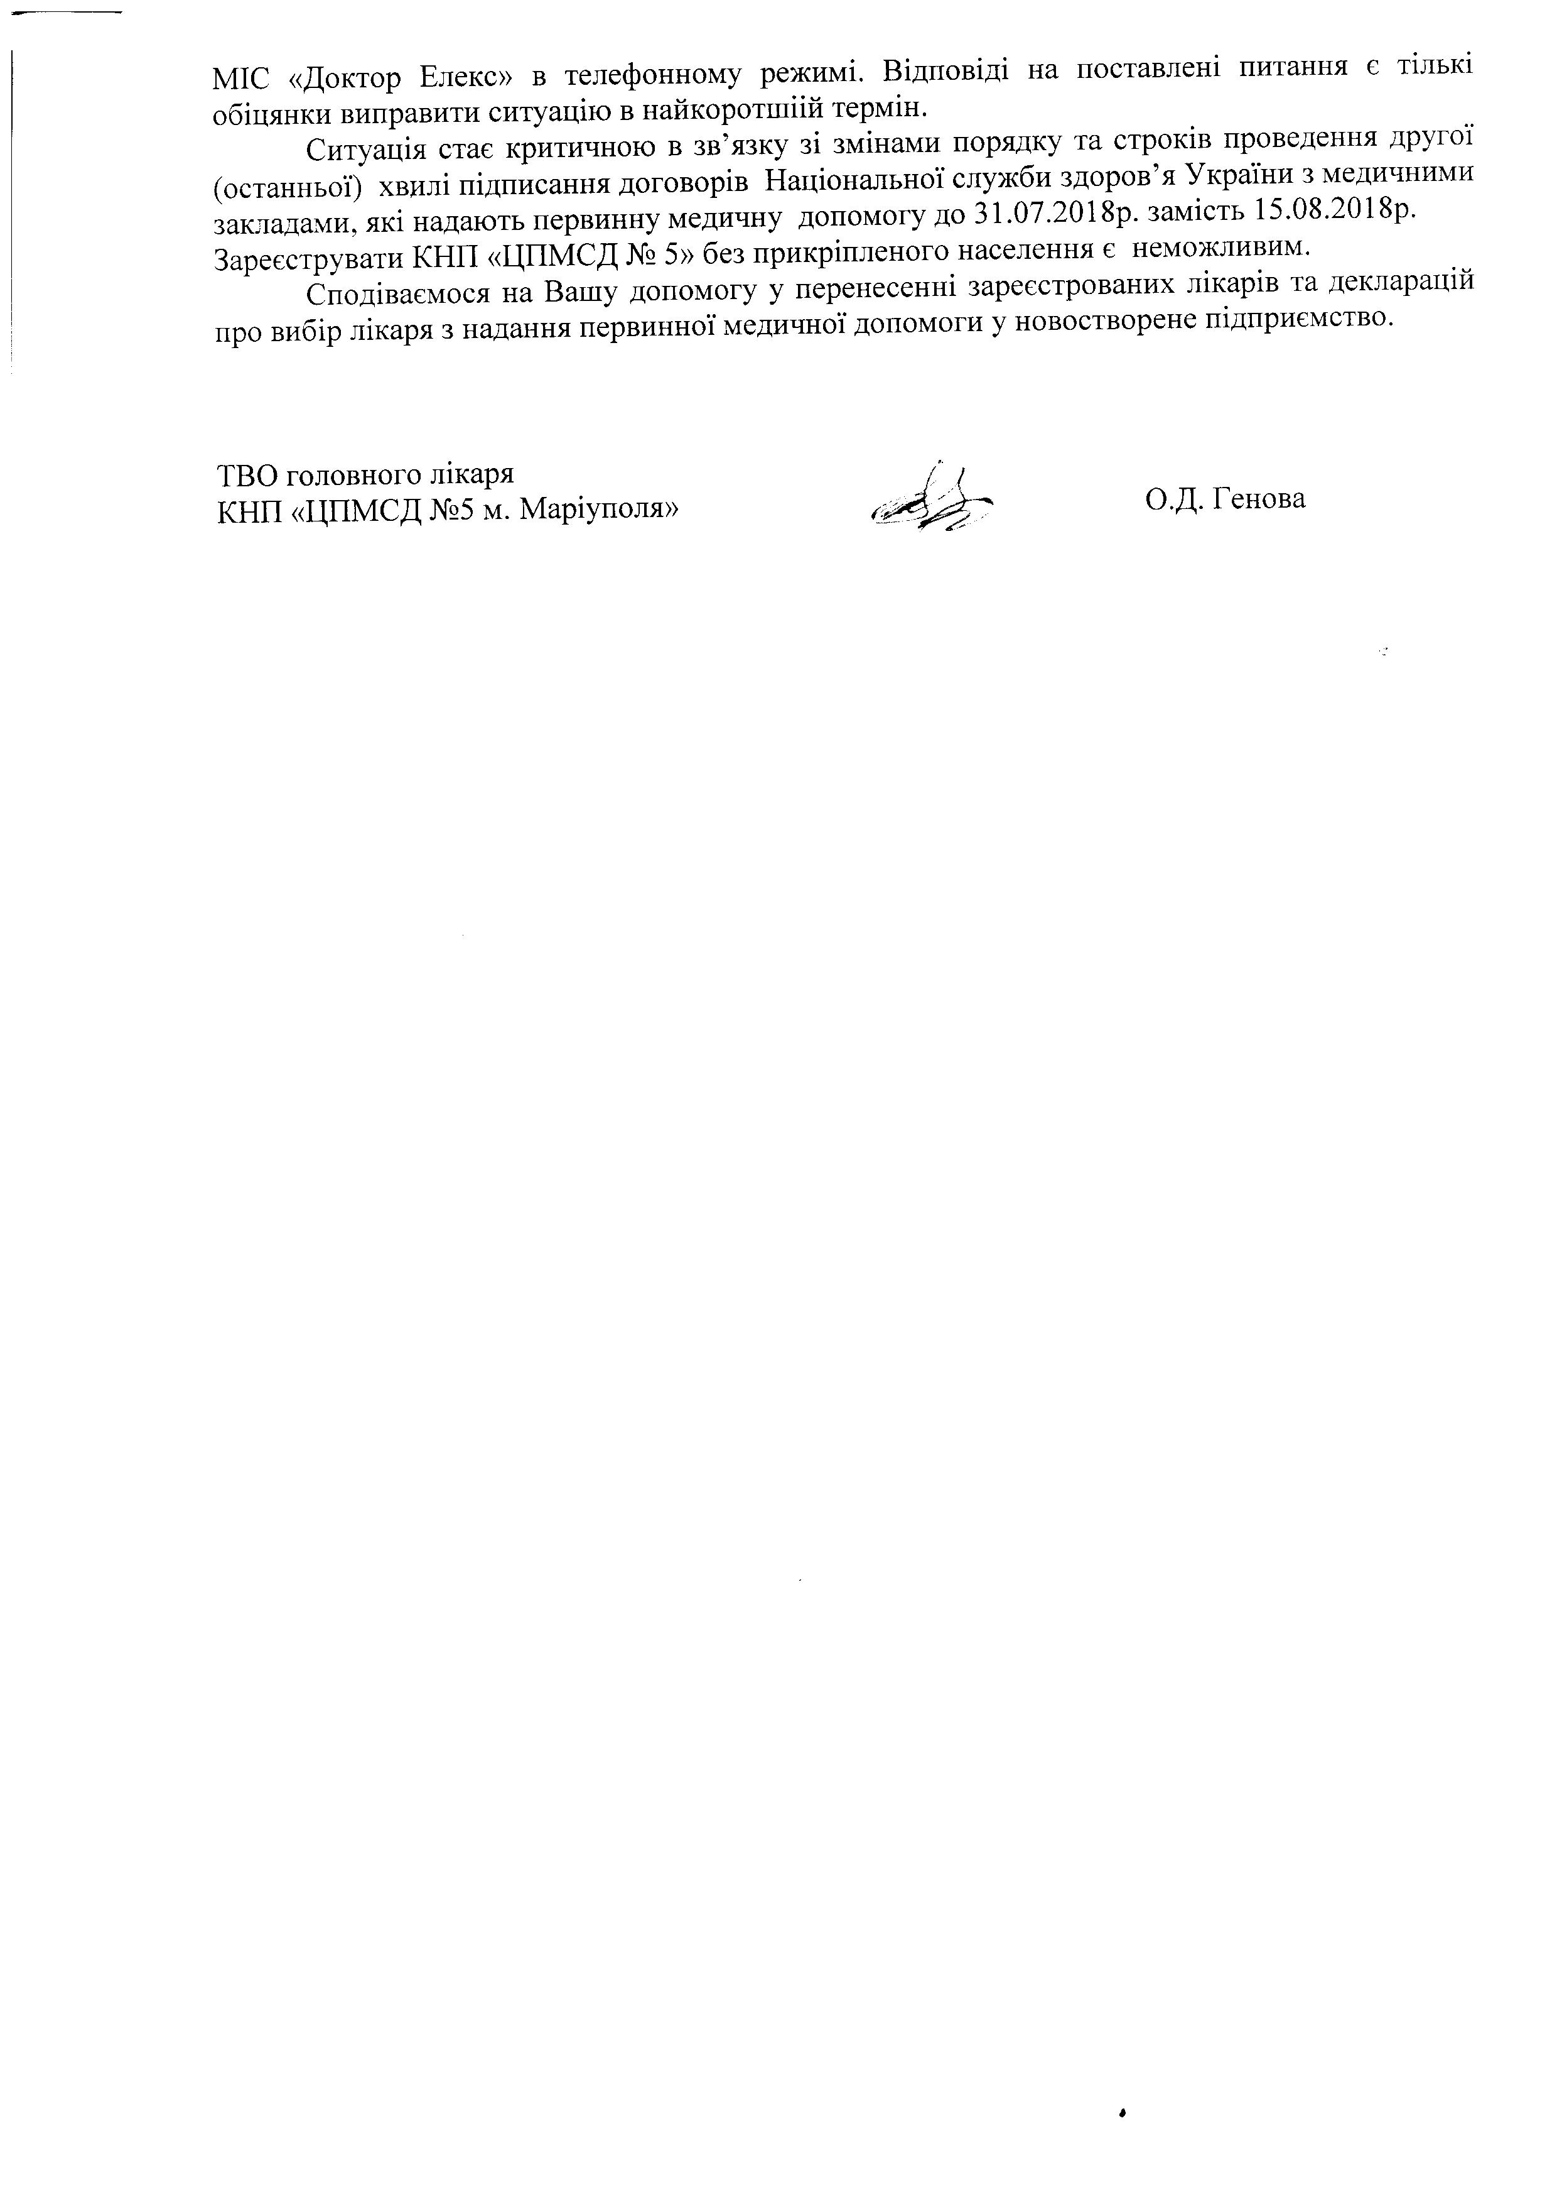
_{MIC} _{<[orrop} _{E:rerc>} e rene$oHHoMy pexuvri. Bianoni4i Ha rlocraBneni ^{narasuq} ^{e} ^{rirrrKi}
_{o 6} iqqHrcu BI{rIpaBL{rI'Icl'Iryallirce uafi rop oruriifi ^{repu} ^{in'}
_{Cutyatlx} _{cra€} _{Kprrrr.rtrHoro} u ,u;"rny si ^{glaiHaNa[} noptAKy ra ^{crpoxin} ^{npoBeAeHHr 4pyroT}
(ocrauHroij *"nni niAnucannx |  |  |  |  | Yr<paiuu 3 MSAETTHUMI{
 |  | HalliouanrHoi clyx6u :4opon'r
^oronopis |  |  | 31 .07.2018p. :anicm 15.08'2018p'
.u*nu.qur", sKi Haaarcrb rrepBr.rHHy MeAurrHy AorloMory lo |  |  |  |  | HeMoxrIpIBI{M'
_{3apeecrpynaru} KHII (I]ilMCA J\b 5) 6e: nprarpillrleHofo ^{HaceneHHt} ^{e}
_{Cno.qinaeuocr} _{Ha} Bamy _{AorroMory} y tt.p."...nni sapeecrpoBaHl4x ^{:rixapin} ^{ra} ^{4exnapauifi}
npo nn6ip :rixapx 3 HaAaHHs nepeunuoi |  | AoIIoMorI4 |  | y HoBocTBopeue ni4upIl€McTBo'
 | rraeAu'{Hoi
TBO rononnoro lixaPr |  |  |  |  | O.[. fenona
KHII (UIIMCA Ns5 N,{. MaPiYnorx>

